Contact #  ANKITA KELKAR  +91 9730443415  +91 9689612353  E-mail  ankitakelkar.physio@gmail.com  IAP: L19393  Permanent Address  Flat # A2-204  Kumar Papillon,  Near Abhinav Arts College,  Sus Road, Pashan,  Pune, Maharashtra  411021 – INDIA.  Date of Birth  7th September 1985  Gender: Female  Nationality: Indian  Marital Status: Married  Languages to  Read, write, and speak:  English, Hindi, Marathi | Career Objective:  Work Experience  Functions as Physio Therapist  - Assessment and Evaluation: To determine patient’s specific needs and develop an appropriate treatment plan.  - Treatment Planning: Create a personalized treatment plan that addresses the patient's goals.  - Exercise and Rehabilitation: Guide patients through therapeutic exercises designed to improve their range of motion, strength, flexibility, and endurance.  - Manual Therapy: Employ manual therapy techniques to alleviate pain, improve tissue flexibility, and enhance overall function.  - Patient Education: Educate patients and their families about their condition, the importance of adherence to the treatment plan, and techniques for self-care.  - Equipment and Assistive Devices: Assess the need for assistive devices and provide recommendations for appropriate equipment.  - Progress Monitoring and Documentation: Regularly assess and document the patient's progress throughout the treatment process to measure the effectiveness of interventions and guides adjustments to the treatment plan as needed.  - Communication and Collaboration: Communicate and Collaborate with other healthcare professionals involved in the patient's care.  - Empathy and Support: Providing emotional support and motivation to patients and their families is an integral part of the job.  Academic Qualification  Strengths  - Excellent interpersonal and communication abilities  - Critical thinker and analysis driven  - Ability to work effectively within a multidisciplinary team  - Outstanding organizational and time management skills  - Proficient in using electronic medical record (EMR) systems  - Dedication to continuous learning and professional growth  - Proficient in MS Office applications  Awards & Achievements  - 1st Rank in University in Post Graduation [M.P.T Sports]  - Research paper Selected in 12th Asian Federation of sport medicine congress held at Amritsar on Dec. 5th, 6th 2009  - Secured 3rd Position in Poster Presentation titled LOOSENING TECHNIQUE IN SPORTS in National workshop on Exercise Science Organized by Physiotherapy College & School of Studies in Physical Education, Pt. Ravi Shankar Shukla University, Raipur (C.G.)  Declaration  I hereby solemnly affirm that all the details provided above are true to the best of my knowledge. I shall carry myself in a manner that lends dignity to the organization.
  Seeking to reignite my professional journey and leverage my skills, knowledge, and experience as a highly motivated and adaptable woman seeking to restart her career. Committed to pursuing new opportunities and challenging roles where I can contribute effectively while embracing growth and continuous learning. | 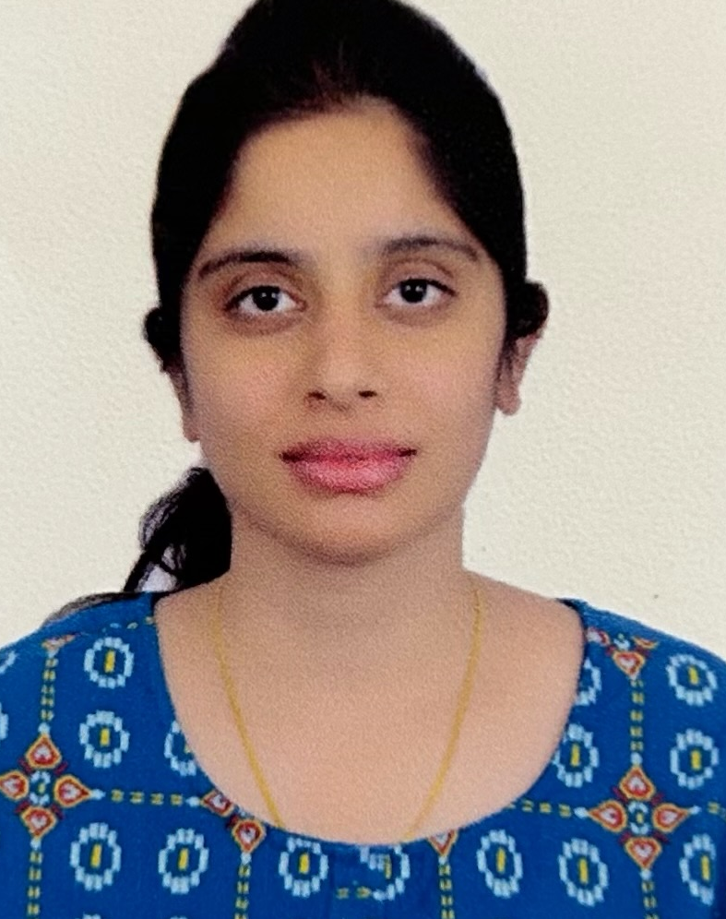
  Consultant
  Self-Employed | Jan 2018 to July 2019
  - Providing rehabilitation services and personalized care to patients within the comfort of their own homes.
  Physio Therapist
  Sancheti Institute for Orthopedics and Rehabilitation [SIOR], Pune | Dec 2010 – May 2015
  - Worked as Physio Therapist at Shivaji Nagar branch
  - Shifted to Aundh satellite center in Mar 2013, where I helped the administration to set up the new center and operationalize the patient care
  - Was involved in day-to-day operations of the center as Center Head
  - Lead and managed the physiotherapist team at Sancheti Clinic, Aundh
  - Patient data handling and analysis for various projects
  Official Physio
  Maharashtra Cricket Association, Women | Aug 2014 – Apr 2015
  - Worked with Maharashtra Women’s Cricket team as Official Physio Therapist for one season
  - Managed daily physical activity routine and playing schedules for the team
  - Tenure coincides with that of Sancheti Hospital as this was not a full-time job and required services only when team was travelling
  Part-Time Lecturer
  DDBM College, Raipur | July – Nov 2010
  - Taught Physiology
  Master of Physiotherapy | Oct 2007 - July 2010
  Pt. Ravishankar Shukla University, Raipur
  Bachelor of Physiotherapy | Oct 2002 – Sep 2007
  Pt. Ravishankar Shukla University, Raipur
  XIIth Board | 2002
  Chhattisgarh Board of Sec. Education, Raipur
  Xth Board | 2000
  Secondary Board of Education M.P., Bhopal

